Code 1.1.5 } Write a Python program to determine whether a student passed the exam or not based on their marks.

Algorithm :
Step 1 : start
Step 2 : input of marks
Step 3 : comparing the marks if marks is >= to 40 so pass otherwise fail
Step 4 : condition close
Step 5 : stop

Code :
Marks = float(input())
If Marks >= 40 :
Print(“pass”)
Else :
Print(“fail”)

Flowchart :
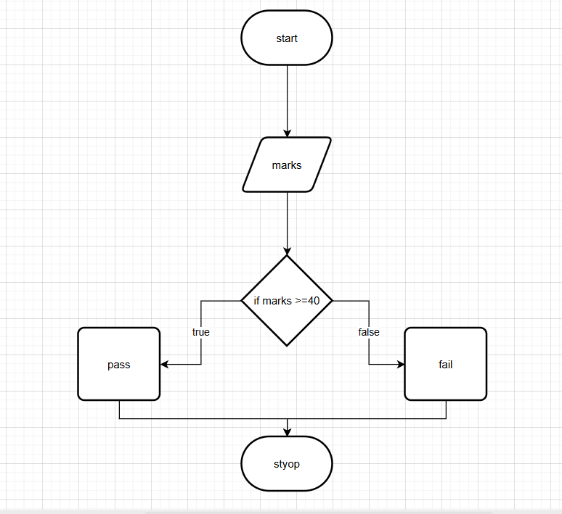

Codetantra :
